Session 4 Assignment 3

Sample ‘Datagen.txt’ file:
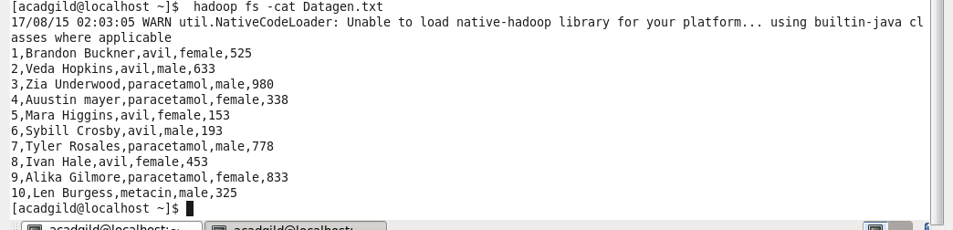

Step1: Loading a sample ‘Datagen.txt’ file in to a variable ‘file’.
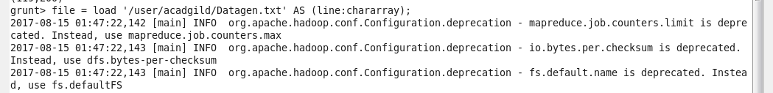

Step2: separating each line and grouping each line

Step3: Counting words in a file and loading in to a variable ‘wordcount’

Step4: dumping wordcount
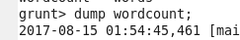

Output:
